Aim: TextRank for Document Summarization
IDE: Google Collab

Theory:
TextRank is an algorithm based on PageRank, which is often used in keyword extraction and text summarization. In this article, I will help you understand how TextRank works with a keyword extraction example and show the implementation in Python.
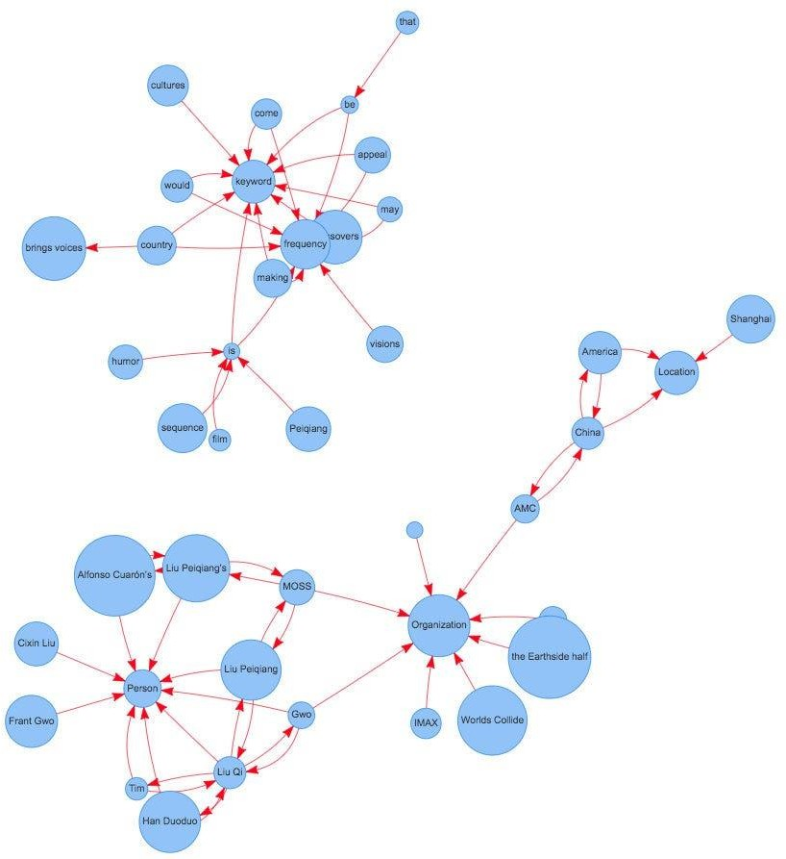

Understand PageRank

There are tons of articles talking about PageRank, so I just give a brief introduction to PageRank. This will help us understand TextRank later because it is based on PageRank. PageRank (PR) is an algorithm used to calculate the weight for web pages. We can take all web pages as a big directed graph. In this graph, a node is a webpage. If webpage A has the link to web page B, it can be represented as a directed edge from A to B. After we construct the whole graph, we can assign weights for web pages by the following formula.

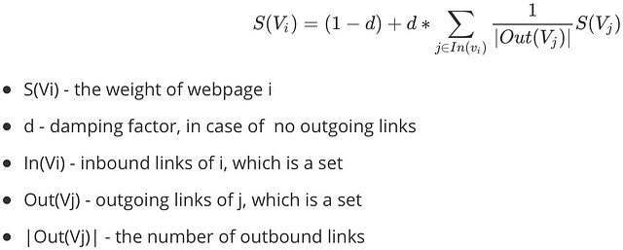
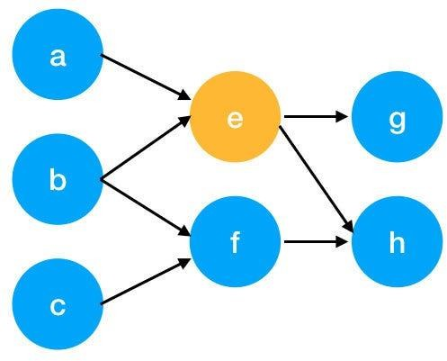

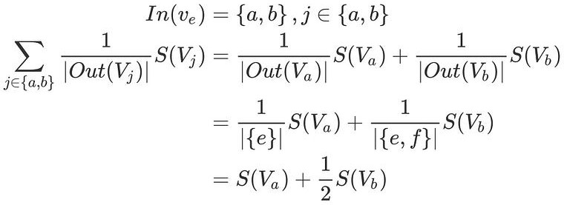
Here is an example to better understand the notation above. We have a graph to represent how web pages link to each other. Each node represents a webpage, and the arrows represent edges. We want to get the weight of webpage e. We can rewrite the summation part in the above function to a simpler version.
We can get the weight of webpage e by the following function.

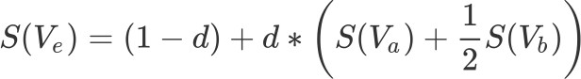

We can see the weight of the webpage e is dependent on the weights of its inbound pages. We need to run this iteration much time to get the final weight. In the initialization, the importance of each webpage is 1.

TextRank for document Summarization
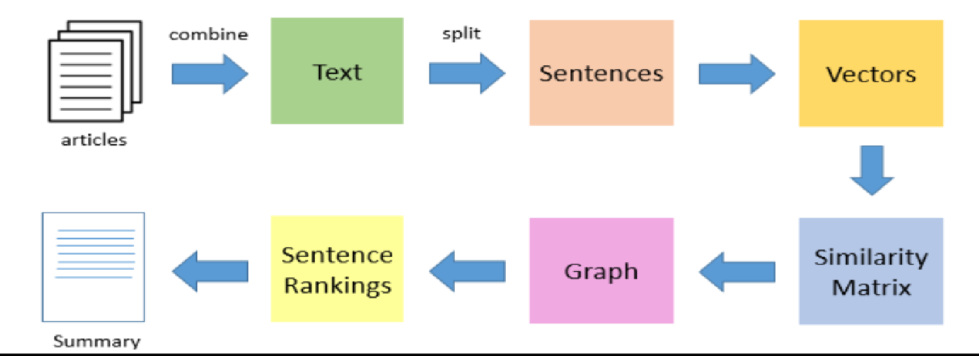

TextRank works in the following steps:
- Tokenize documents into sentences.
- Preprocess each sentence in the document.
- Count key phrases and normalize them or produce TFIDF Matrix, you can also use any kind of vectorization such as spacy vectors.
- Calculate the Jaccard Similarity between sentences and key phrases.
- Rank the sentences with higher significance.

Pre Lab Exercise:
  - How is keyword extraction similar to the document summarization process?
Keyword extraction and document summarization are closely related processes in NLP. Both processes aim to condense the content of a document into a shorter form while retaining the essential information.
- Both processes utilize keywords to retrieve relevant information from a document. Keywords serve as queries that help in finding and summarizing the most important points of the original text.
- Both processes reduce the length of the text, making it easier to read and understand. Summaries and extracted keywords condense the content into a shorter form, reducing the number of words.
- Both processes involve text preprocessing, such as tokenization and removal of stop words, which are essential steps in both keyword extraction and document summarization.
  - How is keyword extraction different from the document summarization process?
The keyword extraction process involves identifying and selecting the most relevant words from a text document. It is used to infer the core sentiment of a document without human intervention and is crucial for tasks such as information retrieval and text categorization.
The document summarization process reduces a text document to a concise set of words that convey its main meaning. It is used to distill the most important information from a document, producing an abridged version for a specific task and user.
  - Limitations of TextRank as a summarizer
The limitations of TextRank as a summarizer are:
- Limited to sentence-level summarization: TextRank is primarily designed for summarizing sentences, which may not be suitable for summarizing entire paragraphs.
- Requires similarity metrics: the algorithm relies on similarity metrics to determine the importance of sentences, which may not always be accurate or relevant in all contexts.
- May not capture contextual meaning: TextRank focuses on the relationships between sentences, which may not fully capture the nuances of the original text.
- Limited to Unsupervised learning: TextRank is unsupervised, meaning it does not require a training dataset, which may limit its effectiveness in certain scenarios.

Program (Code):
import nltk #library for text processing
import networkx as nx #Library used to create and analyze graphs
from nltk.corpus import stopwords #tokenizer to split into words
from nltk.tokenize import word_tokenize
import string

# Download required NLTK datasets
# 'punkt' is used for tokenization
# 'stopwords' provides common English words that can be removed
nltk.download('punkt')
nltk.download('stopwords')

def textrank_keywords(text, window_size=4, top_n=5): #Function to extract keywords using the TextRank algorithm

words = word_tokenize(text.lower())# Convertthe text to lowercase and tokenize it into individual words

stop_words = set(stopwords.words('english'))
words = [w for w in words if w not in stop_words and w not in string.punctuation]

graph = nx.Graph()

for i, word in enumerate(words):
for j in range(i+1, i+window_size):
if j < len(words):
graph.add_edge(word, words[j])

scores = nx.pagerank(graph)

ranked_words = sorted(scores.items(), key=lambda x: x[1], reverse=True)

keywords = [word for word, score in ranked_words[:top_n]]

return keywords
nltk.download('punkt_tab')

text = """
Machine learning is a field of artificial intelligence that uses statistical techniques
to give computer systems the ability to learn from data without being explicitly programmed.
"""

keywords = textrank_keywords(text)

print("Extracted Keywords:", keywords)

Results:

Observation:

Post Lab Exercise:
- Write about “your own self” (in not more than 500 words→ You know better about you, rather than ChatGPT!!). Generate the summary of your portfolio in
  - 50% of the size of your portfolio
  - 25% of the size of your portfolio

Code:
!pip install nltk networkx numpy
import nltk
import numpy as np
import networkx as nx
from nltk.corpus import stopwords
from nltk.tokenize import sent_tokenize, word_tokenize

nltk.download('punkt')
nltk.download('stopwords')
text = """
I am a dedicated and curious student with a strong interest in data science, machine learning,
and problem solving. I enjoy working on real-world projects, especially those related to
engineering applications such as concrete strength prediction. I have experience with Python,
TensorFlow, and data visualization tools like Matplotlib and Tableau.

Throughout my academic journey, I have worked on multiple projects involving machine learning
models, including regression, ensemble learning, and neural networks. I am particularly
interested in improving model performance and understanding how different algorithms behave
under various conditions.

I am also a fast learner and enjoy collaborating with others. I believe in continuous learning
and always look for opportunities to improve my skills. My goal is to become a skilled data
scientist and contribute to solving real-world problems using artificial intelligence.
"""
# Remove stopwords
stop_words = set(stopwords.words('english'))

def preprocess(text):
sentences = sent_tokenize(text)
return sentences

sentences = preprocess(text)
def sentence_similarity(sent1, sent2):
words1 = [w.lower() for w in word_tokenize(sent1) if w.isalnum()]
words2 = [w.lower() for w in word_tokenize(sent2) if w.isalnum()]

all_words = list(set(words1 + words2))

vector1 = [0] * len(all_words)
vector2 = [0] * len(all_words)

for w in words1:
if w not in stop_words:
vector1[all_words.index(w)] += 1

for w in words2:
if w not in stop_words:
vector2[all_words.index(w)] += 1

return np.dot(vector1, vector2) / (
np.linalg.norm(vector1) * np.linalg.norm(vector2) + 1e-10
)
def build_similarity_matrix(sentences):
n = len(sentences)
matrix = np.zeros((n, n))

for i in range(n):
for j in range(n):
if i != j:
matrix[i][j] = sentence_similarity(sentences[i], sentences[j])

return matrix

similarity_matrix = build_similarity_matrix(sentences)
def textrank_summary(sentences, ratio=0.5):
similarity_matrix = build_similarity_matrix(sentences)

graph = nx.from_numpy_array(similarity_matrix)
scores = nx.pagerank(graph)

ranked_sentences = sorted(
((scores[i], s) for i, s in enumerate(sentences)),
reverse=True
)

summary_length = int(len(sentences) * ratio)

summary = [ranked_sentences[i][1] for i in range(summary_length)]

return " ".join(summary)
summary_50 = textrank_summary(sentences, ratio=0.5)

print("\n 50% Summary\n")
print(summary_50)
summary_25 = textrank_summary(sentences, ratio=0.25)

print("\n 25% Summary\n")
print(summary_25)
Output:

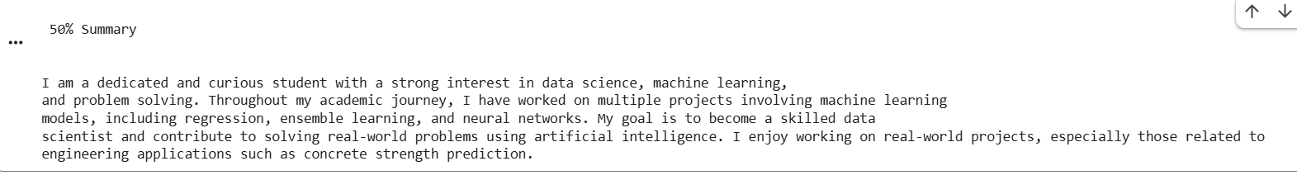

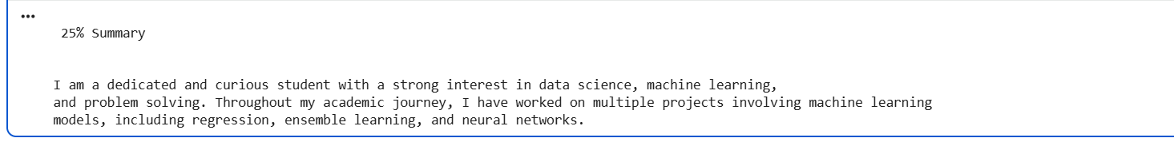
Comment on the summary obtained. Which sentence do you think should be there in your summary, but was not spotted by TextRank? Rate the overall summary on a scale of 1-5 (with 1 as the least and 5 as the highest rating). Paste the code, your portfolio, output, and your analysis.
The summaries obtained using the TextRank algorithm capture the core themes of the portfolio, such as interest in data science and machine learning, experience with projects and models, and career goal of becoming a data scientist. The 50% summary was fairly comprehensive and included both technical experience and career goals, making it informative and balanced. The 25% summary, however, was more limited and mainly focused on background and academic work, missing some important personal and skill-based aspects.
The overall summary is 4 out of 5. Because of the missing technical skills sentences, slight bias toward general statements over specific details.

